

EVENT MANAGEMENT PLAN (EMP): TEMPLATE
(May 2023)


INTRODUCTION

Mansfield Shire Council is committed to ensuring the health and safety to anyone staging or participating and attending an event within the Shire.

By completing an Event Management Plan (EMP), event organisers demonstrate their desire to carry out their legal duties in the management of events in regard to the health and safety of all participants. The EMP will assist you to manage foreseeable risks associated with the staging of the event.

The EMP will also assist council in issuing permits where applicable and help to identify any risks event organisers may not have considered.

The event description is broad and can be quite confusing as it indicates that something as simple as having a party, wedding etc at home would require an EMP.

To eliminate any doubts about what your event requires, please contact our events team to see if a permit or EMP is required via e mail at events@mansfield.vic.gov.au

What is an event or public activity?

An event is any organised activity held on private or public land where an open area, facility, venue, road or temporary structure is to be used by more people than usually found in that location. This activity may affect the location prior to the event, during and after the event.

Expectations and commitments regarding events within the Mansfield Shire

- Mansfield Shire Council expects organisers of any event staged to complete an EMP. You can use Council’s EMP template or develop/construct your own to suit your particular event.

- All stakeholders participate through consultation to deliver a safe and successful event, each sharing responsibility for one another.

- Event organisers will endeavour to identify and manage risks/hazards and where possible eliminate them.

- Event organisers will work with all regulatory and all other authorities to ensure compliance with relevant legislation.

- Where no guidelines exist, event organisers will actively work with our partners and stakeholders to achieve best practices.

- The ultimate goal is to stage a successful event with no harm to people or damage to the environment and property.

- Events ought to contribute a net positive to community and business.

EVENT MANAGEMENT PLAN

Event Title
Venue
Date/s

DOCUMENT HISTORY

Version No. | Date Draft Created | By Whom | Details/Amendment to Draft
01
02
03
04
05
06
07
08
09
10

DISLAIMER: Whilst all care has been taken in the preparation and revision of this document, (and all supplementary documentation), no responsibility will be accepted by the author for any errors, omissions or inaccuracies. This document has been produced to provide a working resource to manage the operational and logistical elements of the listed event in order for the event to be conducted in a safe and professional manner: it is not intended to be
a substitute for legal or other professional advice. The completion and submission to relevant stakeholders of this document does not remove the responsibility of the company/producers to ensure all obligations under legislation are adhered to. No responsibility can be accepted for any known or unknown consequences that may result from reliance on information provided in this document.

3

EVENT MANAGEMENT PLAN
EVENT DETAILS
Event Overview 6
Event Contacts 7
Event Venue/s 8
Insurance Details 8
Event Schedule 9
STAKEHOLDER NOTIFICATIONS
General Detail – Event Notification 10
Sample Stakeholder Notification 11
SITE MAP 12
SITE INFRASTRUCTURE LIST 13
EMERGENCY MANAGEMENT
Hazards & Risks 14
Key Locations 15
Emergency Control 15
Security 16
Pedestrian Management 16
Parking and Drop-offs/Pick-ups 17
Taxis 17
Event Transport 17
Traffic Management 17
Onsite Communications 18
First Aid 18
Incident Responses 19

4

EVENT MANAGEMENT PLAN
HEALTH
Vendors 20
Alcohol 20
Drinking Water 20
Toilets 20
Waste Management and Cleaning 21
POWER AND LIGHTING
Event Power 21
Event Lighting 21
SUSTAINABILITY
Sustainability Planning 22
Site Impact and Reinstatement 22
ACCESSIBILITY 23
General Accessibility 23
SIGNAGE 24
Signage List 24
Signage Overview 24
Signage Sample 24
APPENDIX 26

5

EVENT DETAILS

EVENT OVERVIEW

Name of Event
Event Venue
Event Address

Bump-in Dates/Times
Event Dates/Times
Bump-out Dates/Times
Expected Attendance
Daily Capacity
Ticketing
Event Description
Activities
Target Audience
Promotion
Patrons + Peak Times

6

EVENT CONTACTS

EVENT COORDINATOR

Contact Name
Event Role
Address
Contact Number
Contact Email
Web Address

ASSISTANT COORDINATOR

Contact Name
Event Role
Address
Contact Number
Contact Email
Web Address

KEY EVENT CONTACTS

Name | Role | Number | Email

7

EVENT CONTACTS

EVENT VENUE/S

Venue Contact Name
Venue Contact Role
Venue Contact No.
Venue Contact Email
Venue Name
Venue Address
Venue Email
Venue Website
Venue Map Link
Venue Capacity
Local Government

INSURANCE DETAILS

Public Liability Insurance
Other

DOWNLOAD LOCAL LAWS APPLICATION HERE

8

EVENT SCHEDULE

Date | Time | Activity

Contingency Plan
Cancellation:
Postponement:

9

STAKEHOLDER NOTIFICATIONS

GENERAL DETAIL – EMERGENCY SERVICES EVENT NOTIFICATION

Notification
Distribution | Police, Fire, Ambulance, SES
Content Overview
Recipients
Date of Release
Distributed By
Distribution radius

GENERAL DETAIL – EVENT NOTIFICATION

Notification
Distribution
Content Overview
Recipients
Date of Release
Distributed By
Distribution radius

10

SAMPLE EVENT NOTIFICATION

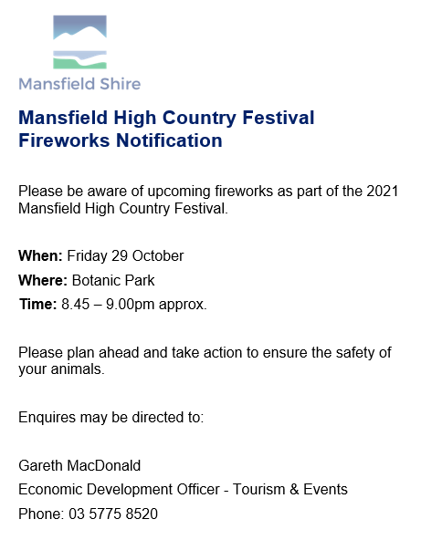

11

SITE MAP

12

SITE INFRASTRUCTURE LIST

ITEM | QTY | Size | Purpose/Use | Location

13

EMERGENCY MANAGEMENT

Risk & Incident Management
This is one area of your event planning that is critical in ensuring your event occurs safely and without incident.

The first steps are to develop a Risk Assessment, which is designed to

- Identify potential hazards associated with your event
- Take steps to minimise or eliminate the risk prior to your event taking place

Potential hazards

Some examples of hazards to consider could be (but are not limited to):

- Security, people/crowds
- Weather
- Plant, hazardous substances/dangerous goods, legal compliance issues, planning, accessibility
- Manual handling
- Slips /trips/falls
- Contractors
- Vehicle safety
- Electrical safety
- Fire safety (eg slashing of car park areas, smoking on site)
- Working at heights OH&S
- Food safety (ensuring all proposed vendors have supplied copies of required permits)
- Disabled Access

You can use the Risk Assessment Table in Council’s EMP appendix or you are welcome to use your own design as long as it lists the foreseeable hazards at the selected site and the actions implemented to minimise the risk.

Is an essential part of your planning. An Emergency Management Plan must identify who will be the responsible person at the event that can call the emergency services and activate (with the assistance of other event staff) an evacuation (if required).
The plan will clearly identify emergency exits, emergency procedures and telephone numbers along with a site map to show all services and evacuation/assembly areas for event staff, patrons and performers, plus access and egress points for emergency services, locations of fire-fighting equipment and first aid post.

How will communication be conducted in the event of an emergency or incident?

14

Key Locations

EVENT OPERATIONS CENTRE (EOC)
EOC | Location | Contact Number
EMERGENCY CONTROL CENTRE (ECC) If not located at Event Operations Centre
ECC | Location | Contact Number
EMERGENCY VEHICLE ACCESS POINT
Vehicle Access Point | Location
EVACUATION ASSEMBLY POINTS
Primary Assembly Point
Secondary Assembly Point

SECURITY
Main Checkpoint | Location | Contact Number
FIRST AID
Main Checkpoint | Location | Contact Number

Emergency Control
The event is managed by the following key staff members:

Name | Role | Phone | Email

15

SECURITY

Details of Services available
Security Provider
Security Location
Rostered Hours
General Security Duties

PEDESTRIAN MANAGEMENT

Infrastructure utilised
Pathway diversions
Pathway closures
Date & time of infrastructure installation
Date & time of infrastructure removal
Location & identification of safety marshals
Date & time of pathway closures
Date & time of pathway openings
Public Transport: Pick-Up point
Public Transport: Set-Down point
Accessibility

16

PARKING AND DROP-OFFS/PICK-UPS
Contractor Deliveries
Contractor Parking
Patron Drop-offs/Pick-ups
Patron Parking

TAXIS
Taxi Rank Location
Details re Taxis

EVENT TRANSPORT
Event Transport Provisions
Details re Transport Provisions

TRAFFIC MANAGEMENT

Locations & types of Infrastructure utilised
Locations of VMS Signage
Text displayed on VMS
Signage Text
Roadway closures
Date & time of infrastructure installation
Date & time of infrastructure removal
Date & time of roadway closures
Date & time of roadway openings

17

ONSITE COMMUNICATIONS
RADIO #
RADIO Allocation – Name
Role (for Call Out sign)
Channel
1
2
3
4
5
6
7
8
9
10
11
12

# NAME NUMBER Channel
1
2
3
4
5
6
7
8
9
10
11
12
Comms channels are as follows (if applicable for radio):

CHANNEL # | CHANNEL ID
1 | Emergency
2 | Event Management
3 | Security
4 | Bars
5 | Cleaning
6 | Spare

FIRST AID

First Aid
Details of Services available
First Aid Provider
First Aid Location
Rostered Hours

18

INCIDENT RESPONSES

Extreme Weather
- Move patrons under cover and away from temporary infrastructure, indoors if possible
- Ensure that marquees are cleared of patrons
- If possible, pack down any loose furnishings or infrastructure onto the ground (trestle tables, folding chairs, umbrellas, signage etc)
- Ensure that all stages and structures are moved into safe mode: stage roofs lowered, marquees cleared and made safe where possible (walls closed up), all loose infrastructure brought inside or lowered
- Report the status of your area to the event coordinator
- Proceed to evacuate immediately if safe to do so

Fire
Should you become aware of Smoke, first advise the coordinator & enact an investigation of the source. Should you become aware of Fire, quickly assess the situation, and call 000 before immediately advising the coordinator. You can attempt to put it out if the fire is smaller than 1m2 and you have ready access to a fire extinguisher/blanket. If it is larger than 1m2, then (if safe to do so) assist any persons nearby to find a Safe Exit or Place of Safe Refuge. Evacuate to the nearest Emergency Assembly Area.

Lost Children
- Lost Child/Person – look for the parent/guardian in immediate vicinity
- After 5-10 minutes, have coordinator take lost child to Lost/Missing Child/Person Point
- Inform coordinator of situation and follow their instructions

Medical Incident (Serious)
- Quickly assess the situation and call 000 if you deem the emergency to be serious
- Alert coordinator and advise that you have contacted 000
- Render assistance to patient if able until First Aiders arrive then assist if required
- Radio for First Aid on Channel 1 or call coordinator
- Commence Incident Report or take notes for treatment and follow-up

Incident Reporting - See appendix for example Incident Report Form

19

HEALTH

VENDORS – ALL FOOD AND DRINK VENDORS MUST COMPLETE A STREATRADER APPLICATION - https://streatrader.health.vic.gov.au/

Food Vendors
Drink Vendors

Street Trading
ALCOHOL

Alcohol
DRINKING WATER

Free Water
TOILETS

Toilets

20

WASTE MANAGEMENT AND CLEANING

Waste Management
Details of Services
Waste Management Provider
WM Staging Location
Rostered Hours

Cleaning
Details of Services
Cleaning Provider
Cleaning Staging Location
Rostered Hours

POWER AND LIGHTING

EVENT POWER

Power

EVENT LIGHTING

Lighting – Site (exterior)

21

SUSTAINABILITY

- Incorporate the principles of a waste hierarchy in the planning, delivery and evaluation phase of their event, including waste avoidance, resource recovery strategies and sustainable purchasing
- Will, where possible, apply a plastic wise approach throughout the event planning and setup, delivery and clean up and pack down. This includes a move to reusables and recyclables and the elimination of single use plastic items in food and use of drink outlets
- Ensure stallholders and caterers use appropriate recyclable or certified compostable packaging without compromising public health and safe food handling regulations
- Implement resource recovery systems (bin stations) effectively at all public events and activities within the area.

EVENT SUSTAINABILITY PLANNING

Event Sustainability Measures

SINGLE USE PLASTIC FREE EVENTS

Single use Plastic Free Events Measures

SITE IMPACT AND REINSTATEMENT

Site Impact – Environmental

SPECIAL EVENTS WASTE & RECYCLE COLLECTION APPLICATION CLICK HERE

22

ACCESSIBILITY

Mansfield Shire Council encourages you to assess your event with accessibility in mind.
Start with the Accessible Events Guidelines checklist AVAILABLE HERE.

GENERAL ACCESSIBILITY

Access to Event Locations

Access within Event Locations

Accessibility Technologies
Accessible Facilities and Amenities
Toilets

Accessible Provision of Information

Accessible Emergency Procedures
Staff Training – Awareness and Sensitivity

23

SIGNAGE
SIGNAGE LIST

SIGN | QTY | TYPE | INSTALL LOCATION

SIGNAGE OVERVIEW

Directional and Way-Finding Signage

Event and Operational Signage

Handbills, Programs and Collateral

Signage Sample
24

CONTACT US

33 Highett St,
Mansfield, VIC, 3722

Telephone: 5775 8555
Email: events@mansfield.vic.gov.au




APPENDIX

- INCIDENT REPORT SHEET

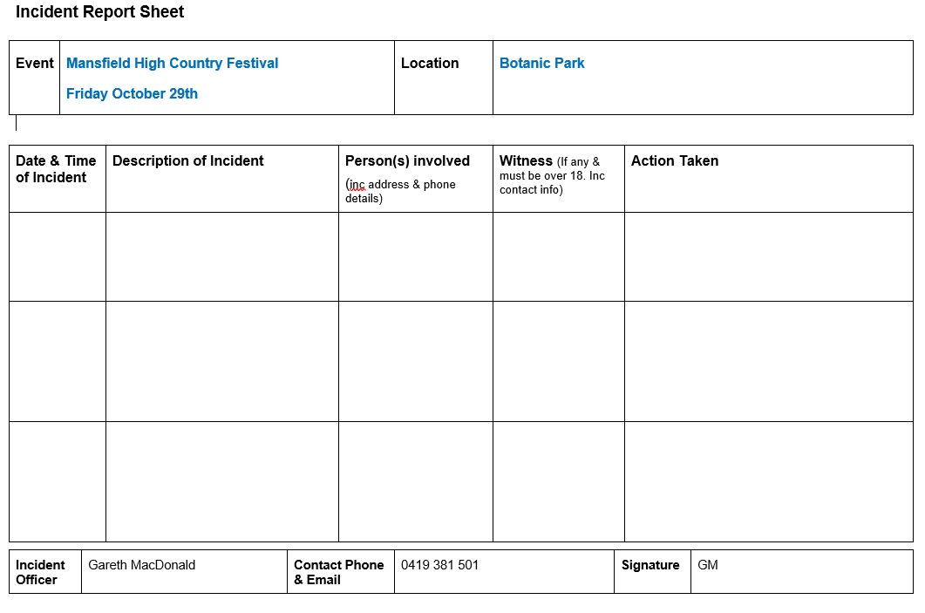

- SITE MAP

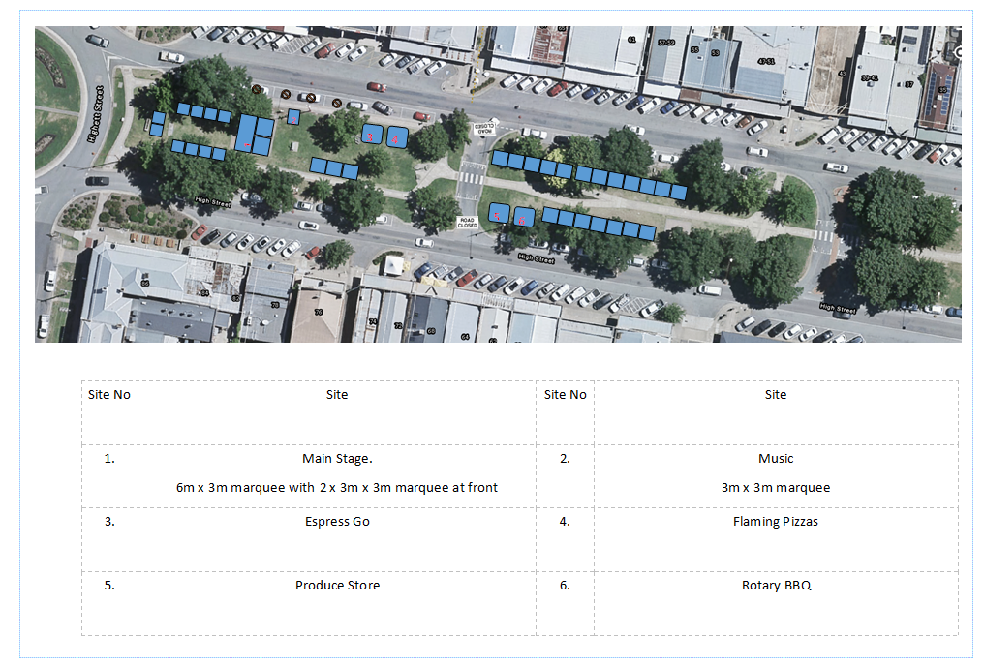 26

- RISK ASSESMENT TABLE
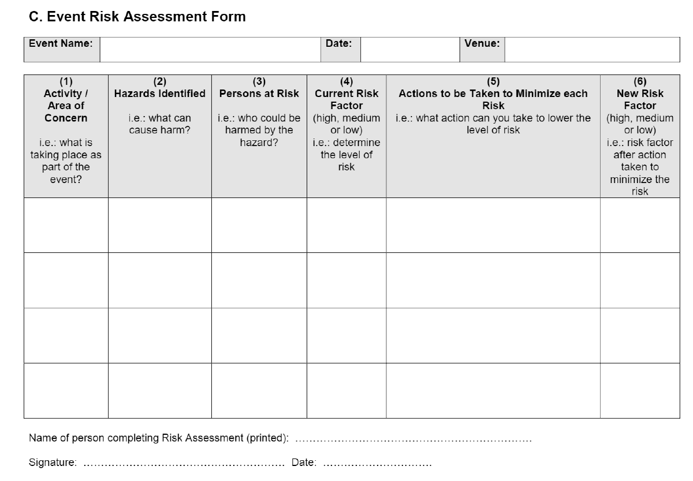
- TRAFFIC MANAGEMENT/ALTERATION ADVICE

To the resident,

This is to advise that the event:

Between Times:
At the following location:
Will be held on:
Event Description / Event Activities:
Anticipated numbers:

To assist your organizations, we have included in the detailed briefing to all traffic controllers:

1. Immediately there is an emergency involving police, ambulance or CFA sirens the event will be stopped (if required).
2. Emergency service members will be provided immediate access to travel through access points in response to the siren or emergency.
3. That the event will not be recommenced (unless safe to do so) until it is clear of all responders and emergency vehicles involved in the incident.

Please note that this correspondence is a requirement of the Mansfield Shire Council for events as part of the traffic management strategy.

Contact person during the event is:
Name:
Mobile ph:

- EMERGENCY SERVICES NOTIFICATION

Police | Mansfield Police  OIC (Officer In Charge) | MANSFIELD.UNI@police.vic.gov.au
Ambulance | North East Head Office  Mansfield Unit | events@ambulance.vic.gov.au  Mansfield.teammanager@ambulance.vic.gov.au
CFA | North East Operations Manager | region23@cfa.vic.gov.au
Hospital | Mansfield District Hospital | reception.main@mdh.org.au
Copy - Council | Tourism & Events  Co-ordinator | events@mansfield.vic.gov.au

- USEFUL CONTACTS

Mansfield Shire Council
Tourism & Events Co-ordinator | 5775 8520  events@mansfield.vic.gov.au
Local Laws | 5775 8539  locallaws@mansfield.vic.gov.au
Waste Management | 5775 8580  waste@mansfield.vic.gov.au
Environmental Health Unit | 5775 8544  locallaws@mansfield.vic.gov.au
Planning Unit | 5775 8533  planning@mansfield.vic.gov.au
Mansfield Visitor Information Centre | 5775 7000  visitorinfo@mansfield.vic.gov.au
Risk Management Officer | 5775 8555  council@mansfield.vic.gov.au
Emergency Services
Mansfield Hospital | 5775 8800  Reception.main@mdh.org.au
Mansfield Police  Officer In Charge | 5775 2555  MANSFIELD.UNI@police.vic.gov.au
Ambulance Victoria | Mansfield : 5775 2254  Mansfield.teammanager@ambulance.vic.gov.au  Or events@ambulance.vic.gov.au
CFA Region 23  Wangaratta | Ph: 5720 2300  Region23@cfa.vic.gov.au
Regional Roads (Benalla) | 5761 1888/131171  nriw.ntheastern@roads.vic.gov.au
SES Mansfield | 5775 2811  mansfield@ses.vic,gov.au
Event First Aid

St John’s Ambulance | 8588 8588  www.stjohn.org.au
North East Training and Licensed event first aid | 5777 3237  info@northeasttraining.com.au
Other Organizations

Goulburn Murray Water  Gary Fox | 5774 3942  garyf@g-mwater.com.au
DELWP - Shane O’Brien  Parks Vic – Bart Smith | 5733 1236  Shane.obrien@delwp.vic.gov.au  basmith@parks.vic.gov.au
EPA Victoria | 1300 372 842  contact@epa.vic.gov.au
Mansfield Courier | 5775 2115  edit.mcourier@nenews.com.au
Mansfield Community Radio | 5775 2333  enquiries@radiomansfield.org.au
APRA (Music performances)  Australasian Performing Rights Assoc | Ph. 9426 5200  www.apra.com.au

