I request that ______ waste and _______ recycle (insert no. of bins) special event bins are supplied and emptied in accordance with the details below and conditions referred to over page.
COST: $26.00 per bin, including GST.
I request that ______ waste and ______ recycle (insert no. of bins) special event bins are emptied only in accordance with the details below and conditions referred to over page. (Please note: applicant to supply own bins).
COST: $23.00 per bin, including GST.
Date of Application: ______/________/_______
Name of Applicant: _________________________________________________
Committee/Event Name: _________________________________________________
Account Details (name _________________________________________________
& address of person to _________________________________________________
send account to): _________________________________________________
Contact Phone Number: ________________________

Name of Festival / Event:
Address for delivery & collection of bins:
Date bins are to be delivered to the site:
Date bins to be emptied & or removed from the site:
Additional Comments:

A separate application is required to be submitted for each event.
Applications must be received by Council at least two weeks prior to the event.

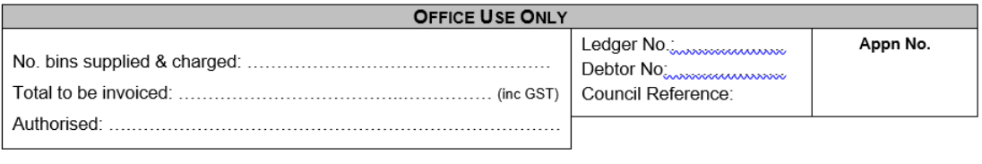
I confirm that I have read and agree to the conditions of this service and request Council arrange a special events waste collection in accordance with the details provided. As the applicant, I acknowledge that I am responsible for ensuring all charges associated with this collection are paid.
Applicant Signature: ________________________________ Date _____/_____/_____

Terms & Conditions

- The special events waste and recycle collection provided by Council is a user pays service. The charges detailed below are at contractor costs.

- Special Event Supply and Empty Charges:

- Supply and empty of bins - $26.00 per bin, including GST

Includes the delivery of bins to the nominated address, emptying and removal of empty bins from the site.

- Emptying of bins - $23.00 per bin, per empty including GST

Includes the empty only of bins. Bins must be supplied by the applicant.

- In rural areas the emptying of bins is generally incorporated with the domestic waste collection route.

- Event caps are to be borrowed from Council to be utilised on the event day. The applicant is responsible for collection of the caps prior to the event and ensuring all caps are returned to Council immediately after the event. Please contact Councils Waste Management Officer for collection and drop off location.

- The applicant is responsible for all event caps borrowed from Council. A charge may apply in the instance of missing/damaged event caps to cover the costs of replacing.

- The applicant is responsible for ensuring that event caps borrowed from Council are returned in a clean and odour-free state. A charge may apply for the cleaning of event caps.

- Waste and recycle bins/caps will be placed in stations strategically across the venue as per the recommendations of Councils Waste Unit.

- The applicant agrees that waste and recycle bins will be placed at any location nominated by Council for the emptying or removal of the bins after the event.

- A separate application is required to be submitted for each individual event.

- Applications must be received by Council at least two weeks prior to the event to ensure the service can be provided.

- The applicant is responsible for all charges levied as a result of this application.

- There is no refund or discount should the applicant require less than the nominated collections, unless arrangements have been made with Council to alter the service requirements prior to the delivery/emptying of bins.

- The applicant applies to the Mansfield Shire Council for the removal of waste from the event stated overleaf.

- The mobile garbage bins are picked up using a specially equipped truck. The bin must be placed on the back of the kerb and channel or edge of the shoulder of the roadway as appropriate. The handle (and wheels) must be facing AWAY from the road.

- Hot ashes, solvents, heavy metals or liquids are not to be placed in the MGB or MRB.

