Date of Application: ­­­ _______/________/_______

Name of Business: _________________________________________________

ABN/ACN: _________________________________________________

Waste Collection Address: _________________________________________________

Postal Address for Correspondence: _________________________________________________

Name of Ratepayer for Property: _________________________________________________

Contact Phone: _________________________________________________

Council Assess No: ­­­­­­­­­­­­­­­­­ _________________________________________________

❑

❑

I request that a **commercial recycle collection service is provided** to the above-mentioned business, in accordance with the details below.

Please **cancel the commercial recycle collection service** provided to the above-mentioned business.

* I request to have _______ (insert number) of 240 litre mobile recycle bins collected on a regular, fortnightly basis from the above premises and understand that an annual recycle charge for the collection of each of these bins will be included in the rates for property assess no ____________.**\***

**\* Ratepayer approval required. Applicants must pay a minimum of one annual charge – refer Mansfield Shire Council Waste Collection Conditions of Supply and Service.**

* I have a maximum of _________ (insert number) additional 240 litre mobile recycle bins that may require collection during busy periods, and understand that the collection of these ‘additional’ bins will be charged monthly at the commercial rate.
* Please order ­­_________ recycle bins to enable participation in a fortnightly commercial recycle service.
* Please order _________ yellow lids to enable garbage bins on-site to be converted to recycle bins to enable participation in a fortnightly commercial recycle service.

**2023-2024 Annual Recycle Charge 2023-2024 Commercial Recycle Bin**

(240 litre mobile recycle bin)  **Collection Charge**

(240 litre mobile recycle bin)

**$169.05 per annum $12.00* per bin, per collection**

*GST free

($96.00 fee for delivery and provision of bin)

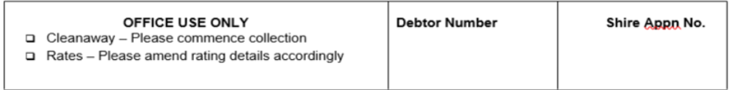

I confirm that I have read and agree to the Conditions of Supply and Service.

Applicant Signature: ________________________________

Applicant Name: ___________________________________ (please print) Date: _____/_____/_____