Date of Application: ­­­ _______/________/_______

Name of Business: _________________________________________________

ABN/ACN: _________________________________________________

Waste Collection Address: _________________________________________________

Postal Address for Correspondence: _________________________________________________

Name of Ratepayer for Property: _________________________________________________

Contact Phone: _________________________________________________

Council Assess No: ­­­­­­­­­­­­­­­­­ _________________________________________________

❑

❑

I request that a **commercial garbage collection service is provided** to the above-mentioned business, in accordance with the details below.

Please **cancel the commercial garbage collection service** provided to the above-mentioned business.

* I request to have _______ (insert number) of 240 litre mobile garbage bins collected on a regular, weekly basis from the above premises and understand that an annual garbage charge for the collection of each of these bins will be included in the rates for property assess no ____________.**\***

**\* Ratepayer approval required. Applicants must pay a minimum of one annual charge – refer Mansfield Shire Council Waste Collection Conditions of Supply and Service.**

* I have a maximum of _________ (insert number) additional 240 litre mobile garbage bins that may require collection during busy periods, and understand that the collection of these ‘additional’ bins will be charged monthly at the commercial rate.
* Please order ­­_________ waste bins to enable participation in a weekly commercial garbage service.

**2023-2024 Annual Garbage Charge 2023-2024 Commercial Garbage Bin**

(240 litre mobile garbage bin)  **Collection Charge**

(240 litre mobile garbage bin)

**$561.99 per annum $14.00* per bin, per collection**

*GST free

($96.00 fee for delivery and provision of bin)

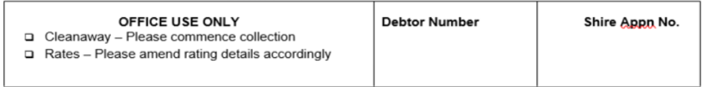

I confirm that I have read and agree to the Conditions of Supply and Service.

Applicant Signature: ________________________________

Applicant Name: ___________________________________ (please print) Date: _____/_____/_____