As part of any good planning process hazards should be identified and risks assessed and controlled to minimise the potential for injury or harm. Events vary in size, nature and type, but all events require assessment, control and monitoring of risks.

Council requires that before an event is held on Council or public land, relevant permits and licenses are obtained and that a risk assessment and Event Management Plan is completed and forwarded to Council.

Risk Assessment – It’s a must

The success of your event is measured in many ways and safety is one of them. As part of any good planning process hazards should be identified and risks assessed and controlled to minimise the potential for injury or harm. Events vary in size, nature and type, but all events require assessment, control and monitoring of risks.

While most of us understand this, we can find it difficult to apply to a working event document, such as Risk Registers or Risk Control Plans. Remember to start with something simple and build on it. It will become an invaluable tool that you can use to assess event safety – from the planning phase right through to the overall evaluation of the event.

This guide breaks down the risk assessment process, outlining each step

Hazard Identification
Hazard identification is the process of recognising hazards associated with an event. It is helpful to identify risks by considering the people involved, and their roles to ensure their safety at all times

Hazard ‘groupings’ that can assist in the identification process include:

• human - type and size of crowd expected, level of crowd participation
• technological - mechanical, utilities such as gas and electricity
• natural - the physical location and site area conditions
• environmental - weather, Environment Protection Authority controlled, ground impact etc.

Risk Assessment

Risk assessment is the process of estimating the potential effects or harm of a hazard to determine its risk rating. By determining the level of risk, event organisers can priorities risks to ensure systematic elimination or minimisation.

In order to determine a risk rating consider:

• the consequence - what will happen, the extent of harm; and

• the likelihood - chances or possibility of it occurring.

A risk assessment matrix modelled from examples given in AS/NZS ISO 31000 Risk Management. When conducting a risk assessment, include the people who are actually involved in undertaking the task. Experience is as important as a fresh perspective when undertaking risk assessment

Risk Control
In order to control the risk, we need to work out the best method of handling the risk. Look at the following methods, which are referred to as the ‘hierarchy of controls’, to see if you can eliminate or reduce the risk.

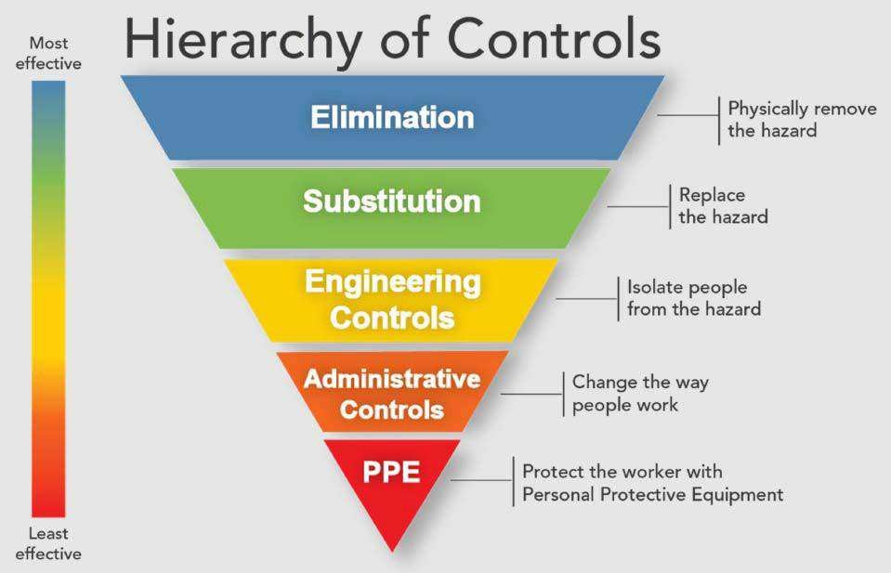

Often people pick the ‘easier’ option by going straight to administrative controls or PP but there are often more effective ways to control the hazard. In many cases consultation and discussion with the people involved reveals new ideas or better ways of handling hazards and reducing the risks of injury. Focus on what is both realistic and practical so that risks are minimised to an acceptable level. It is vital to ensure that risk assessment covers the entire event – from set up (bump in) to dismantling (bump out), not just during the event itself.
Most importantly, consult with those involved.

Risk Assessment Table
Likelihood
How likely is it to occur? (example of a risk table below)
Likelihood Ratings Table
Likelihood | Description | Quantification
A Almost Certain | The event is expected to occur in normal circumstances.  The event has occurred frequently in the past. | Several times a year.
B Likely | The event will probably occur.  The event has occurred occasionally in the past. | Once a year.
C Possible | The event may occur sometime.  There have been warning signs the event might occur. | Once every 5 years.
D Unlikely | The event could occur in some circumstances. No past event history. | Once every 20 years.
E Rare | The event may occur but only in exceptional circumstances.  No past event history. | Once every 50 years or more.

Consequence
What is likely to be the impact? (Below is a guide to use as a reference)

Consequence | Example Detail Description
5 Minimal | - No injuries  - Low financial loss
4 Minor | - First aid treatment  - On-site release of chemical immediately contained  - Temporary halt of event  - Medium financial loss
3 Moderate | - Medical treatment required  - On-site release of chemical contained with outside assistance  - Temporary halt of event requiring outside assistance (e.g. specialised maintenance, fire, Police)  - High financial loss
2 Major | - Extensive injuries  - Loss of production capability  - Off-site release of chemical with no detrimental effects  - Halt of event requiring investigation and outside assistance (e.g. fire, police, ambulance, SafeWork NSW)  - Major financial loss
1 Severe | - Death  - Toxic release off-site with detrimental effect  - Halt of production with investigation and potential prosecution (e.g. fire, police, ambulance, SafeWork NSW)  - Catastrophic financial loss

Risk Assessment Matrix
Risk Rating
The risk matrix determines a ‘risk rating’, based on the likelihood and consequence of risk.

Risk Rating Matrix
 | Consequence
Likelihood | 5 Minimal | 4 Minor | 3 Moderate | 2 Major | 1 Severe
A Almost Certain | Medium | High | High | Very High | Very High
B Likely | Medium | Medium | High | High | Very High
C Possible | Low | Medium | Medium | High | High
D Unlikely | Low | Low | Medium | Medium | High
E Rare | Low | Low | Low | Medium | Medium
Ratings
VH = Very High risk: immediate action required
H = High risk: senior management attention needed
M = Medium risk: responsibility must be specified
L = Low risk: manage by routine procedures
Risk assessment tables enable event organisers to allocate risk ratings to all hazards, so they can prioritise and address them in a system.

Risk Assessment example
Name of Event: | Exact Location of Event:
Date and time of event: | Expected number of attendees:
“Event Manager/Organiser” name, address and telephone number: | Person completing Risk Assessment:

1 | 2 | 3 | 4 | 5 | 6 | 7 | 8 | 9
Risk Statement | Consequence | Likelihood | Inherent Risk Rating | Controls | Control Effectiveness | Consequence | Likelihood | Residual Risk Rating
E.g. – Event cancelled due to unforeseen reasons, including wet weather | Minimal | Possible | Low | Wet weather plan developed and implemented | Minimal | Possible | Low | Communications Plan implemented through social media with reasons for cancellation
1 | 2 | 3 | 4 | 5 | 6 | 7 | 8 | 9
Risk Statement | Consequence | Likelihood | Inherent Risk Rating | Controls | Control Effectiveness | Consequence | Likelihood | Residual Risk Rating
E.g. – Event cancelled due to unforeseen reasons, including wet weather | Minimal | Possible | Low | Wet weather plan developed and implemented | Minimal | Possible | Low | Communications Plan implemented through social media with reasons for cancellation

